**{{ event_name }} Speaker Packet**

{{ dates }} | {{ time }}

{{ location_name }}

{{ location_address }}

**{{ event_name }} Event Audience:**

{{ event_audience_details }}

**Expected Audience: {{ expected_attendance }}**

**Speaker Hosts**

The following people are your production contacts + hosts during the event.

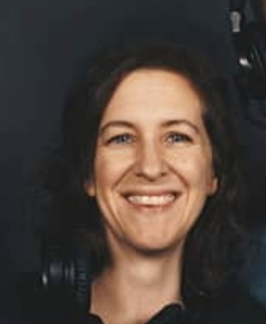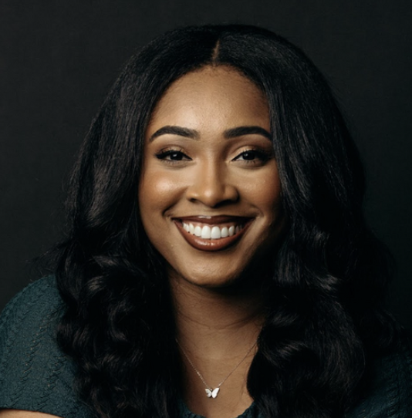

**Account LeadSpeaker Host**

{{ host_name_1 }} {{ host_name_2 }}

Cell: {{cell_phone_1 }} Cell: {{cell_phone_2 }}

Please reach out to Event Producer for any questions **pre-event** at insert email and insert phone number.

**Event Parking/Drop Off: -**

{{ parking_details }}

**Attire**

* Please no small patterns, solid white, or solid black.
* We recommend you bring 2 attire options.

**Confidence Monitors + Teleprompter**

There will be confidence monitors available for your notes and/or presentations. You will be able to advance with a perfect cue, or we can advance for you.

If you have a script, we can display the script on a large TV teleprompter next to the camera platforms.

*If you have notes or presentations to display, please send them to {{ event_producer_email }}, by* ***{{ deadline }}****.*

**Stage + Design**

{{ stage_layout }} {{ design }}

| **SCHEDULE** |
| --- |

**Insert Date**

| **Time** | **What** | **Who** |
| --- | --- | --- |
| **{% for row in schedule %}** |  |  |
| **{{ row.time }}** | **{{ row.what }}** | **{{ row.who }}** |
| **{% endfor %}** |  |  |